MINI PROJECT REPORT
ON
ELECTION DATA ANALYTICS AND VISUALIZATION DASHBOARD

Submitted By

Roll No. | Name | PRN
23 | Anmol Tiwari | 1032233432
24 | Rohan Gude | 1032233452
27 | Shravani Pathrikar | 1032233422
28 | Yash Dharurkar | 1032233440

TY. CSE (Panel E) | Course: Project Based Laboratory IV

Under the Guidance of
Prof. Priyanka Rajmane

Department of Computer Engineering and Technology
MIT World Peace University, Kothrud, Pune 411038, Maharashtra — India
Academic Year: 2025–2026

ABSTRACT
India conducts the world's largest democratic elections, involving over 900 million registered voters across 28 states, 8 union territories, and approximately 4,120 Lok Sabha and Assembly constituencies. The sheer scale and complexity of Indian election data — encompassing candidate information, party-wise votes, voter turnout, margin of victory, and demographic details — pose significant challenges for centralized analysis and informed decision-making.
This project presents the design and development of an interactive Election Data Analytics and Visualization Dashboard using Microsoft Power BI and Tableau. The dashboard integrates a Pan-India election dataset sourced from the Election Commission of India (ECI), the Trivedi Centre for Political Data (TCPD), and Kaggle, covering both Lok Sabha and State Assembly elections spanning six decades (1962–2024) across the entire country. The dataset comprises over 100,000 candidate-level records with 38+ attributes.
Four interactive dashboards were developed — three in Microsoft Power BI and one in Tableau — to represent the data in a structured and visually compelling manner. Key outputs include: KPI cards displaying total votes (612M for 2019 Lok Sabha), average voter turnout (70.54%), candidate count (541), and party representation (37 parties); party-wise vote distribution charts revealing BJP's commanding 71.39% vote share in the 2019 general elections; state-wise scatter plots for margin analysis; gender-based turnout visualizations; age-versus-vote-share trend analysis; and geographic constituency heat maps.
The solution employs Power Query for data cleaning and transformation, DAX (Data Analysis Expressions) for dynamic KPI calculations, and a star schema data model for efficient relational queries. The dashboard supports multi-dimensional filtering by state, party, year, and constituency, with cross-highlighting and drill-down capabilities enabling granular political analysis. This tool serves as a valuable resource for political analysts, electoral researchers, media organizations, and policymakers seeking data-driven insights into India's democratic processes.

LIST OF FIGURES
- Fig 1: Election Analytics Dashboard – Lok Sabha (Power BI)
- Fig 2: Election Analysis Dashboard – Lok Sabha KPIs View (Power BI)
- Fig 3: Election Analytics Dashboard – Assembly Election (Power BI)
- Fig 4: Indian Election Dashboard – Historical Overview (Tableau)
- Fig 5: EDA (Exploratory Data Analysis) Flow
- Fig 6: KPI Cards – Key Performance Indicators
- Fig 7: Sum of Votes by Party – Bar Chart
- Fig 8: Total Votes by State – Treemap
- Fig 9: Voter Turnout % – Gauge Visual
- Fig 10: Vote Share State-wise – Scatter Plot
- Fig 11: Winning Margin by Constituency – Bar Chart (Tableau)
- Fig 12: Total Votes by Age – Line Chart
- Fig 13: Female Candidates by Party – Bar Chart
- Fig 14: How Age Affects Vote Share – Scatter Plot
- Fig 15: Electors in States – Choropleth Map (Tableau)
- Fig 16: Year-wise Voter Turnout – Line Chart (Tableau)
- Fig 17: Dashboard Wireframe / Design Layout
- Fig 18: Test Cases Summary

LIST OF TABLES
- Table 1 — Data Corrections
- Table 2 — Performance Enhancements
- Table 3 — Sample Election Records
- Table 4 — Functional Requirements
- Table 5 — Non-Functional Requirements
- Table 6 — Dataset Overview
- Table 7 — Dimensions
- Table 8 — Measures
- Table 9 — Missing Value Analysis
- Table 10 — KPI Summary
- Table 11 — Tools & Technologies
- Table 12 — Visual Types and Rationale
- Table 13 — Data Model (Star Schema)
- Table 14 — Test Cases

TABLE OF CONTENTS
Chapter | Title | Page
1 | Introduction | —
2 | Problem Identification | —
3 | Requirement Analysis | —
4 | Dataset Description | —
5 | Attribute Analysis (Dimensions vs. Measures) | —
6 | Exploratory Data Analysis (EDA) | —
7 | Data Cleaning & Transformation | —
8 | Key Performance Indicators (KPIs) | —
9 | Tools & Technologies | —
10 | Visualization Approach | —
11 | Dashboard Design | —
12 | Dashboard Screenshots & Explanation | —
13 | Implementation Details | —
14 | Design (Wireframe) | —
15 | Testing | —
16 | Refinement | —
17 | Feedback | —
18 | Conclusion | —
19 | References | —

1. INTRODUCTION
India is the world's largest democracy, and its electoral process is a complex, multi-tiered mechanism that generates enormous volumes of data at every election cycle. General elections (Lok Sabha) and state legislative assembly elections together involve hundreds of millions of voters, thousands of candidates, and hundreds of political parties competing across thousands of constituencies. The effective analysis of this data is crucial not only for academic research and political strategy but also for ensuring electoral transparency, accountability, and public awareness.
In this project, we analyse historical Indian election data spanning multiple election years (1962–2024) and derive actionable insights using data visualisation techniques. Four interactive dashboards are developed — three in Microsoft Power BI and one in Tableau — to represent the data in a structured and visually compelling manner. The dashboards enable stakeholders to understand electoral trends, party performance, constituency-level behaviour, and the influence of demographic factors such as age and gender on voting patterns.
Business Intelligence (BI) tools such as Microsoft Power BI have emerged as powerful platforms for transforming raw data into meaningful insights through interactive dashboards. Power BI's capabilities — including real-time filtering, drill-down analysis, DAX-powered calculations, and cross-visual highlighting — make it ideally suited for building a comprehensive election analytics solution. Tableau complements this by enabling rich geographic visualizations and historical multi-decade trend analysis.

1.1 Scope of the Project
The dashboard covers:
- Lok Sabha General Elections (1962 to 2024)
- State Legislative Assembly Elections across all major states
- All recognized national and regional political parties
- Constituency-level, district-level, and state-level granularity
- Demographic analysis including gender and age of candidates and voters

2. PROBLEM IDENTIFICATION
Despite the richness of Indian election data, extracting meaningful insights from it remains challenging due to the scale, multi-dimensionality, and heterogeneity of the datasets. Key problems identified include:

2.1 Fragmented and Siloed Data
Election data in India is published at the state level in heterogeneous formats — separate PDF files, Excel sheets, and HTML tables — without a unified schema. Data for 543 Lok Sabha constituencies and thousands of assembly constituencies across 36 states/UTs is maintained in disparate systems, making cross-state analysis extremely difficult. Party names, constituency spellings, and state names often differ across datasets, introducing data inconsistency.

2.2 Difficulty in Analyzing Voter Trends
Identifying multi-election voter behavior trends — such as incumbency advantages, swing constituencies, regional party emergence, and turnout decline — requires joining datasets across years and dimensions. This is nearly impossible using traditional spreadsheet tools when dealing with 100,000+ records spanning multiple election cycles.

2.3 Absence of Real-Time Insights
Current data dissemination by ECI is primarily static — PDF press releases and HTML tables updated post-election. There is no interactive system where a political analyst can dynamically filter by party, year, state, and constituency to answer questions like: 'Which constituencies in Maharashtra saw the closest elections in 2024?' or 'How has BJP's vote share changed in eastern UP since 2014?'

2.4 Manual Reporting Limitations
Manual compilation and reporting of election statistics is time-consuming and error-prone. News organizations, political researchers, and policy institutes often spend weeks aggregating and cleaning election data before any analysis can begin. This delay diminishes the actionability of insights.

2.5 Lack of Demographic Visibility
Gender representation in Indian elections — particularly the proportion of female candidates fielded versus elected — is rarely tracked centrally. Similarly, age-based voting patterns and candidate age distributions are understudied. A centralized dashboard with demographic filters addresses this gap directly.

3. REQUIREMENT ANALYSIS

3.1 Functional Requirements
FR No. | Requirement | Description
FR-01 | Multi-State Data Integration | Load and consolidate election data from all 28 states and 8 UTs into a unified data model.
FR-02 | Party-Wise Analysis | Display total votes, seat count, and vote share percentage for each political party.
FR-03 | State-Wise Analysis | Enable filtering and visualization of election results at individual state and UT level.
FR-04 | Constituency-Level Drill-Down | Allow users to drill from state-level to individual constituency results.
FR-05 | KPI Tracking | Display dynamic KPI cards for Total Votes, Average Turnout %, Average Margin, Candidate Count, and Party Count.
FR-06 | Interactive Filtering | Support slicers for State, Constituency, Year, Party, and Constituency Type (GEN/SC/ST).
FR-07 | Demographic Analysis | Visualize gender-wise candidate distribution and age-vs-vote-share trends.
FR-08 | Multi-Year Comparison | Support filtering across multiple election years for longitudinal trend analysis.
FR-09 | Cross-Tool Integration | Develop dashboards in both Power BI and Tableau for complementary analysis capabilities.
FR-10 | Geographic Visualization | Display choropleth maps of elector counts and constituency-level winning party distributions.

3.2 Non-Functional Requirements
Category | Requirement
Performance | Dashboard response time for filter operations must be under 3 seconds even with 100,000+ records.
Scalability | The data model must support expansion to include future elections without architectural changes.
Usability | The dashboard must be navigable by non-technical users (political analysts, journalists) with minimal training.
Data Accuracy | KPI calculations must match official ECI-published totals within a 0.01% margin of error after data cleaning.
Reliability | All visual interactions (cross-filtering, drill-down) must function correctly across all filter combinations.
Maintainability | The Power Query transformation pipeline must be documented and modular to enable updates with new election data.

4. DATASET DESCRIPTION

4.1 Overview
The project utilizes a comprehensive Pan-India election dataset aggregating data from the Election Commission of India (ECI), the Trivedi Centre for Political Data (TCPD), Kaggle, and MyNeta candidate records. The dataset covers both Lok Sabha general elections and State Legislative Assembly elections across the entire country, spanning six decades from 1962 to 2024.
Parameter | Value
Total Records | 100,000+ (after merging multiple election years)
Total Attributes | 38+ columns per record
Geographical Coverage | All 28 States + 8 Union Territories of India
Constituency Coverage | 543 Lok Sabha + ~4,120 Assembly Constituencies
Election Types | General Elections (Lok Sabha) + State Assembly Elections
Election Years | 1962–2024 (Lok Sabha and Assembly)
Data Granularity | Candidate per constituency per election
Data Sources | ECI, TCPD (Trivedi Centre for Political Data), Kaggle, MyNeta

4.2 Data Tables

4.2.1 Candidate-Level Table (Fact Table)
The central fact table contains one record per candidate per constituency per election. Key fields include Candidate Name, Party, Votes Received, Vote Share %, and whether the candidate won. This table drives all KPI calculations.

4.2.2 Constituency Dimension Table
Contains constituency metadata: Constituency_Name, Constituency_Type (GEN/SC/ST), District_Name, State_Name, and number of electors. Constituencies are the primary geographic unit of electoral analysis.

4.2.3 Party Dimension Table
Contains party-level information: Party abbreviation, full party name, party type (National/State/Registered Unrecognized), and alliance affiliations where applicable.

4.2.4 Election Metadata Table
Contains election-specific attributes: Election_Date, Election_Type (Lok Sabha/Assembly), Year, and State. This enables temporal filtering and multi-year trend analysis across the dataset.

5. ATTRIBUTE ANALYSIS (DIMENSIONS VS. MEASURES)

5.1 Dimensions (Qualitative Attributes)
Dimensions are descriptive, categorical attributes used for filtering, grouping, and providing context to measures. In Power BI, dimensions appear in slicers and as axis categories in charts.
Attribute | Data Type | Description
State_Name | Text (String) | Name of the Indian state or UT
District_Name | Text (String) | Administrative district of the constituency
Constituency_Name | Text (String) | Name of the electoral constituency
Constituency_Type | Categorical | GEN (General), SC (Scheduled Caste), ST (Scheduled Tribe)
Party | Text (String) | Political party name the candidate represents
Candidate | Text (String) | Full name of the electoral candidate
Sex | Categorical | Gender of the candidate (M/F/Other)
Candidate_Type | Categorical | Contest type (Sitting, New, Turncoat)
Election_Type | Categorical | Lok Sabha or State Assembly election
Election_Date | Date | Date of the election event
Incumbent | Boolean | True if the candidate is a sitting/incumbent member
Turncoat | Boolean | True if candidate switched party from previous election
Deposit_Lost | Boolean | True if candidate failed to secure deposit threshold votes
MyNeta_education | Categorical | Candidate's declared educational qualification
TCPD_Prof_Main | Categorical | Candidate's primary profession as per TCPD data

5.2 Measures (Quantitative Attributes)
Measures are numerical values used for calculations, aggregations, and KPI derivation.
Measure | Unit / Type | Political Significance
Votes | Integer (Count) | Raw votes received by a candidate; primary performance metric
Valid_Votes | Integer (Count) | Total valid votes in the constituency; denominator for vote share
Electors | Integer (Count) | Total registered voters in the constituency
Turnout_Percentage | Float (%) | Civic participation metric; Valid_Votes / Electors × 100
Vote_Share_Percentage | Float (%) | Party's share of total valid votes in the constituency
Margin | Integer (Count) | Vote difference between winner and runner-up
Margin_Percentage | Float (%) | Margin / Valid_Votes × 100; indicates contest competitiveness
ENOP | Float | Effective Number of Parties; measures party fragmentation
N_Cand | Integer (Count) | Number of candidates contesting in the constituency
No_Terms | Integer (Count) | Number of terms the winning candidate has served
Age | Integer (Years) | Age of the candidate at time of election

6. EXPLORATORY DATA ANALYSIS (EDA)
Exploratory Data Analysis is performed to understand the structure of the election dataset and identify meaningful patterns before dashboard development.
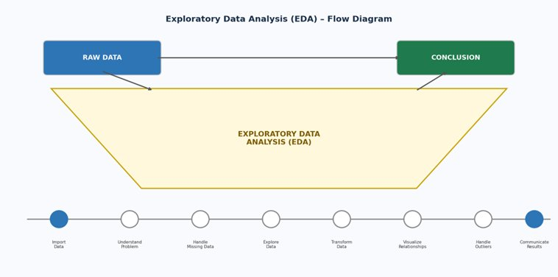
Fig 5: Exploratory Data Analysis (EDA) – Flow Diagram

6.1 Missing Value Analysis
A thorough missing value audit was conducted on the raw dataset before any transformation. The following missing value rates were identified:
Column | Missing % | Action Taken
TCPD_Prof_Second_Desc | ~99% | Column dropped (>85% threshold)
Last_Party | ~85% | Column dropped (>85% threshold)
MyNeta_education | ~24% | Imputed with 'Unknown'
Age | ~6% | Replaced with median age (~51 years)
Sex | <2% | Imputed with 'Unknown'
Candidate_Type | <1% | Imputed with 'Unknown'

6.2 Key EDA Analyses Performed

Time-Based Analysis
Examining how party dominance and voter turnout have changed across election years (1962–2024). Identifying election cycles with peak or trough voter participation.

Geographic Analysis
Mapping vote distribution across states and constituencies to identify regional strongholds and competitive zones. Analysis of the Lok Sabha 2019 dataset reveals significant inter-state variability in total votes cast. Tamil Nadu, Uttar Pradesh, and Maharashtra consistently record the highest absolute vote counts. Union Territories such as Lakshadweep and Chandigarh show markedly lower absolute figures, though their turnout percentages can be competitive.

Party Dominance Trends
The 2019 Lok Sabha dataset reveals a starkly unequal vote distribution among parties:
- Bharatiya Janata Party (BJP): 348 million votes (71.39% vote share)
- Indian National Congress (INC): 56 million votes (11.49% vote share)
- All India Trinamool Congress (AITC): 30 million votes (6.17%)
- Yuvajana Sramika Rythu Congress Party (YSRCP): 28 million votes (5.71%)
- Dravida Munnetra Kazhagam (DMK): 26 million votes

Voter Turnout Distribution
The average voter turnout for the 2019 Lok Sabha election stands at 70.54%. Turnout varies significantly by state: high-turnout states (above 75%) include Lakshadweep, Nagaland, Manipur, and Tripura; moderate-turnout states (65–75%) include Karnataka, West Bengal, Tamil Nadu, and Rajasthan; lower-turnout states (below 65%) include Bihar and Uttar Pradesh.

Demographic Insights
The age-vs-vote-share trend shows candidates in the 35–55 age bracket command the highest vote shares, peaking around age 45–48. Very young candidates (under 30) and elderly candidates (above 70) show significantly lower vote shares, indicating voter preference for mid-career politicians. The gender analysis reveals male candidates command 93.42% of total votes, reflecting the continued underrepresentation of female candidates in Indian electoral politics.

Margin Analysis
The state-wise scatter plot plots Average Margin versus Total Votes for each state. States with high votes but low margins indicate highly competitive electoral zones, while outliers suggest party strongholds. Close elections (margin < 5% of valid votes) are concentrated in Kerala, Bihar, and West Bengal — states with strong opposition parties.

7. DATA CLEANING & TRANSFORMATION
Raw election data from multiple election years required significant preprocessing before it could be used for visual analysis. The following cleaning and transformation steps were carried out using Power Query (Power BI) and data preparation features in Tableau.

7.1 Data Cleaning Steps in Power Query

7.1.1 Handling Duplicate Records
The raw dataset was inspected for duplicate rows using Power Query's 'Remove Duplicates' feature applied on the composite key (Constituency_Name + Candidate + Election_Year). No exact duplicate rows were found, confirming data integrity at the source level.

7.1.2 Standardizing Party and State Names
State name inconsistencies existed across datasets — for example, 'Jammu & Kashmir' vs. 'Jammu and Kashmir', and 'Delhi' vs. 'NCT of Delhi'. Party name formats were also standardized (e.g., 'B.J.P' → 'BJP', 'Indian Natl Cong' → 'INC'). A reference standardization table was created in Power Query mapping all variant spellings to the official ECI-defined names.

7.1.3 Date Transformation
The original dataset stored Year and Month as separate integer columns. These were merged using Power Query's Date.FromText function to create a unified Election_Date column in datetime format. The original Year and Month columns were then removed to avoid redundancy in the data model.

7.1.4 Age Handling and Binning
Approximately 6% of candidate records had missing Age values. These were imputed with the median age (approximately 51 years for Lok Sabha candidates). An age binning calculated column was created (18–35, 36–50, 51–65, 66+) for use in demographic visualizations. Derived fields also include constituency competitiveness tier (margin < 5% = high competition) and gender flag.

7.1.5 Handling Boolean Columns and Categorical Imputation
Four columns — Deposit_Lost, Incumbent, Recontest, and Turncoat — contained string values ('True'/'False') or binary integers (0/1). These were standardized to Boolean datatype. Missing categorical values across Sex, Candidate_Type, Party_Type_TCPD, MyNeta_education, and TCPD_Prof_Main were replaced with the sentinel value 'Unknown'. Columns with greater than 85% missing values — specifically TCPD_Prof_Second_Desc and Last_Party — were dropped. NOTA entries were filtered out for party-level aggregations. A unified State-Year key was created for cross-dataset joins between Lok Sabha and Assembly data.

7.2 Calculated Columns Created
- Vote_Share_Percentage: (Votes / Valid_Votes) × 100
- Margin_Percentage: (Margin / Valid_Votes) × 100
- Age_Group: Binned age into four categories for demographic analysis
- Is_Winner: Boolean flag derived from position rank (Rank = 1 implies winner)
- Constituency_Competitiveness: Flag for margin < 5% of valid votes

8. KEY PERFORMANCE INDICATORS (KPIs)
KPIs are displayed as interactive card visuals at the top of each dashboard page, providing at-a-glance political intelligence that updates dynamically based on active filter selections.
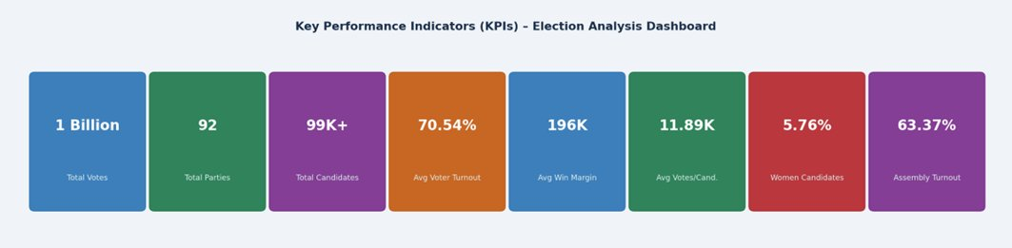
Fig 6: Key Performance Indicators (KPIs) – Election Analysis Dashboard

8.1 Lok Sabha Dashboard KPIs
KPI | DAX Formula | Value | Political Significance
Total Votes | SUM(Votes) | 612M (2019) | Indicates total democratic participation
Average Turnout % | AVERAGE(Turnout_Percentage) | 70.54% (2019) | Measures civic engagement
Average Margin | AVERAGE(Margin) | 196K (2019) | Measures competitiveness across constituencies
Count of Candidates | COUNTROWS(Candidates) | 541 (2019) | Indicates contest density
Count of Parties | DISTINCTCOUNT(Party) | 37 (2019) | Reflects multi-party system diversity

8.2 Assembly Election Dashboard KPIs
KPI | Value | Political Significance
Voter Turnout % | 63.37% | Assembly elections show lower turnout than Lok Sabha
Average Victory Margin | 1.48 (scaled units) | Reflects high competitiveness in state-level elections
Women Candidates % | 5.76% | Critical gender equity metric — persistent underrepresentation
Party Competition Index | 3.66 | ~4 parties meaningfully competing per constituency on average
Total Candidates | 82K | Massive scale of India's state-level democratic participation

8.3 Combined Overview and Tableau Dashboard KPIs
Dashboard | KPI | Value
Combined Overview (Power BI) | Total Votes | 1 Billion (all elections combined)
Combined Overview (Power BI) | Total Parties | 92 distinct parties across all elections
Combined Overview (Power BI) | Total Candidates | 99K across all elections analyzed
Combined Overview (Power BI) | Avg Votes per Candidate | 11.89K
Tableau (Indian Election) | Total Voters (cumulative) | 4,735,081,346 (1962–2020)
Tableau (Indian Election) | Total Parties | 8,047 across six decades
Tableau (Indian Election) | Total Candidates | 6,188 (filtered national view)

9. TOOLS & TECHNOLOGIES
Technology | Version / License | Purpose in Project
Microsoft Power BI Desktop | Latest (2024) | Dashboard development, visualization, publishing — three dashboards built
Tableau | Latest (2024) | Fourth dashboard — historical Indian election geographic and temporal analysis
Power Query (M Language) | Integrated with Power BI | ETL pipeline, data cleaning, transformation
DAX (Data Analysis Expressions) | Integrated with Power BI | KPI calculation, measures, calculated columns
Microsoft Excel / CSV | Office 365 / Open Standard | Data inspection, preliminary cleaning, raw data ingestion
Microsoft Bing Maps API | Microsoft Azure | Geographic constituency map visualization in Power BI
Mapbox / OpenStreetMap | Via Tableau | Choropleth map of Indian states by elector count in Tableau

9.1 Key DAX Functions Used
The following DAX functions were central to building the dynamic KPI calculations:
- CALCULATE() — Modifies filter context for conditional aggregations
- FILTER() — Row-level filtering within measure calculations
- DIVIDE() — Safe division with fallback for zero-denominator scenarios
- SUMX() / AVERAGEX() — Iterator functions for row-level expressions
- DISTINCTCOUNT() — Counting unique party and constituency entries
- RANKX() — Ranking candidates and constituencies by vote count

10. VISUALIZATION APPROACH

10.1 Design Strategy
The dashboards are designed with a focus on clarity, usability, and interactivity. Each dashboard targets a specific analytical lens of Indian elections:
- KPI cards placed at the top for an immediate high-level summary
- Logical grouping of related visuals (party analysis, geographic maps, demographic charts)
- Clean and consistent color schemes — purple/gold for combined overview, blue for KPIs view
- Side-panel filters for State, Party, Year, and Constituency

10.2 Visual Types and Their Rationale
Visual Type | Data Represented | Analytical Rationale
KPI Cards | Total Votes, Turnout %, Candidate Count | Instant high-level summary; decision-first approach
Horizontal Bar Chart | Votes by Party | Enables direct party-to-party vote comparison on a linear scale
Donut/Pie Chart | Vote Share %, Gender Distribution | Proportional representation; visually intuitive for part-to-whole relationships
Gauge Chart | Voter Turnout % | Shows performance against a 0–100% scale; instantly communicates turnout level
Scatter Plot | State-wise Votes vs. Margin; Age vs. Vote Share | Reveals correlation between voter count, competitiveness, and demographics
Geographic Map | Winning Party by State/Constituency; Elector Count | Spatial political analysis; reveals regional party dominance patterns
Line Chart | Age vs. Vote Share; Year-wise Turnout | Shows demographic-political relationship and participation trends over decades
Grouped Bar Chart | Seats Won vs. Votes by Party | Compares raw votes to seat conversion efficiency
Treemap | Total Votes by State | Proportional area representation of state-wise electoral scale
Data Table | State-wise EVM Votes and Victory Margins; Party Performance | Precise numerical reference for detailed analytical verification
Choropleth Map (Tableau) | Electors in States | Geographic distribution of registered voter base across India

10.3 Interactive Features
- Slicers for filtering by State, Party, Constituency, Year, and Constituency Type
- Drill-down from national → state → constituency level
- Cross-filtering: clicking one chart updates all related visuals on the page
- Dynamic tooltips for contextual data on hover
- Avg. Turnout % range slider on the Tableau historical dashboard to filter anomalous data

11. DASHBOARD DESIGN

11.1 Design Philosophy
The dashboard follows a decision-first layout philosophy: the most critical, actionable information — KPI cards — appears at the top of each page, immediately visible without scrolling. This mirrors the inverted pyramid structure used in executive reporting: summary at the top, supporting detail below.

11.2 Layout Architecture (Four-Zone Structure)
- Zone 1 — Top Strip (KPI Cards): Five to six KPI card visuals displayed horizontally, each showing a single key metric with its label.
- Zone 2 — Left Panel (Filters): A vertical filter panel with dropdown slicers for State, Constituency, Year, and Party. Consistently positioned on the left to align with Western reading patterns.
- Zone 3 — Center (Primary Analysis Visuals): The central canvas area contains bar charts for party vote comparison and geographic maps for spatial analysis.
- Zone 4 — Bottom / Right (Supplementary Analysis): Supporting visuals such as the voter turnout gauge, vote share donut chart, age analysis line chart, and data tables.

11.3 Color Coding and Typography
Each political party in the dashboard is assigned a consistent color across all visuals — BJP in orange/saffron tones, INC in blue, and regional parties in distinct identifiable colors. This consistency reduces cognitive load during cross-visual analysis. Dashboard titles use large, bold typography (18–22pt). KPI card values use large numerals (28–36pt) with concise labels. Chart axis labels and legends use 10–12pt font sizes for readability.

12. DASHBOARD SCREENSHOTS & EXPLANATION

12.1 Figure 1: Election Analytics Dashboard — Lok Sabha (Power BI)
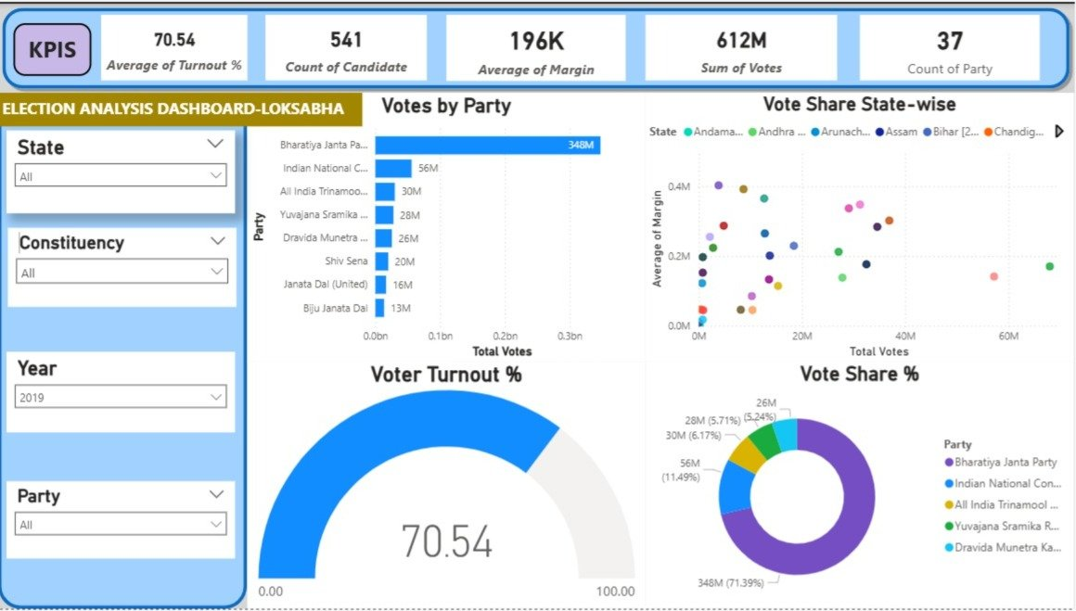
Fig 1: Election Analysis Dashboard – Lok Sabha (Power BI)
Figure 1 presents the primary Lok Sabha election analysis dashboard, currently filtered to the 2019 General Election with all states, constituencies, and parties selected. This dashboard provides a comprehensive overview of national-level election outcomes and is the default landing view for Lok Sabha analysis.

KPI Cards (Top Strip)
- 70.54 — Average Voter Turnout: Historic high for Indian general elections, reflecting heightened national interest.
- 541 — Count of Candidates: Representing the set of analyzed constituencies.
- 196K — Average Margin: Indicates predominantly non-competitive results at the national level.
- 612M — Sum of Votes: Total votes cast across all analyzed constituencies in 2019.
- 37 — Count of Parties: Distinct political parties in the analyzed 2019 dataset.

Sum of Votes by Party (Bar Chart)
This bar chart compares total votes polled by each party across all election years. BJP leads with approximately 0.35 billion votes, followed by INC. Regional parties like SHS, NCP, and IND show significant but smaller vote bases. This highlights the dominance of national parties while reflecting the importance of regional players.

Voter Turnout % (Gauge Visual)
The gauge shows an average voter turnout of 70.54% for the filtered period (2019 Lok Sabha). This exceeds the global average for parliamentary democracies, indicating strong civic engagement in India.

Vote Share State-wise (Scatter Plot)
The scatter plot maps each state as a dot, with X-axis representing Total Votes and Y-axis representing Average Winning Margin. States with high votes but low margins indicate highly competitive electoral zones, while outliers suggest party strongholds.

Key Insights — Lok Sabha Dashboard
- BJP's 71.39% vote share in 2019 represents an unprecedented concentration of voter preference in modern Indian democratic history.
- The average victory margin of 196K votes indicates 2019 was predominantly a non-competitive election nationally — very few constituencies were genuinely contested.
- Regional parties (YSRCP, DMK, AITC) demonstrate significant state-level concentrations driven by near-total dominance in their home states.
- The 70.54% turnout gauge confirms 2019 as one of India's highest-participation elections.

12.2 Figure 2: Election Analytics Dashboard — Assembly Election (Power BI)
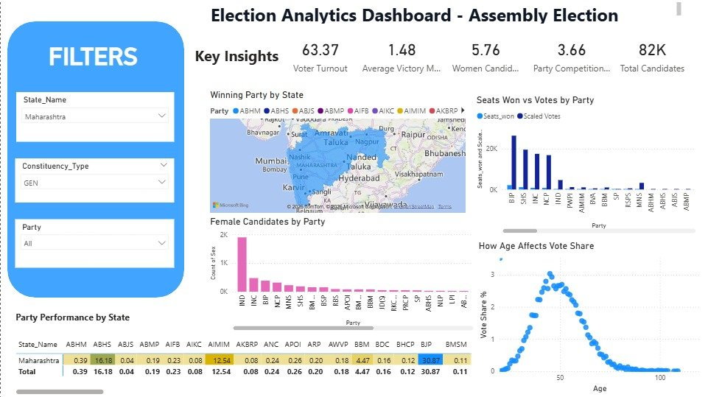
Fig 3: Election Analytics Dashboard – Assembly Election (Power BI)
Figure 2 presents the State Assembly Election analytics dashboard, currently filtered to Maharashtra with General (GEN) constituency type selected. This page focuses on state legislative assembly election analysis, offering deeper insights into state-level party dynamics, demographic participation, and age-based voting patterns.

Total Votes by Age (Line Chart)
The line chart reveals a bell-curve distribution of votes by voter age. Peak voting activity is observed in the 35–45 age group, with a sharp decline for voters above 70. This insight is consistent across both Lok Sabha and Assembly dashboards.

Female Candidates by Party (Bar Chart)
IND and INC field the highest number of female candidates at the Assembly level, followed by BJP. The chart highlights that female political representation remains low overall (5.76% of total candidates), pointing to a systemic gap in gender inclusion in Indian politics.

How Age Affects Vote Share (Scatter Plot)
A scatter plot of candidate age vs. vote share % reveals that candidates in the 35–55 age bracket tend to secure higher vote shares, peaking around age 45. Very young (<25) and older (>70) candidates typically attract lower vote shares.

Key Insights — Assembly Dashboard
- Maharashtra's assembly elections show considerably more competitive dynamics than Lok Sabha, with average victory margin of 1.48% indicating most assembly seats are genuinely contested.
- The gender gap in candidate fielding (5.76% female candidates) is a structural political issue across all major parties.
- The age-vote-share curve peaks at ~47 years, confirming Maharashtra voters favor experienced, mid-career politicians.
- AIMIM's 12.54% average vote share in specific constituencies reflects concentrated electoral strength in Muslim-majority urban areas.

12.3 Figure 3: Combined Overview Dashboard (Power BI)
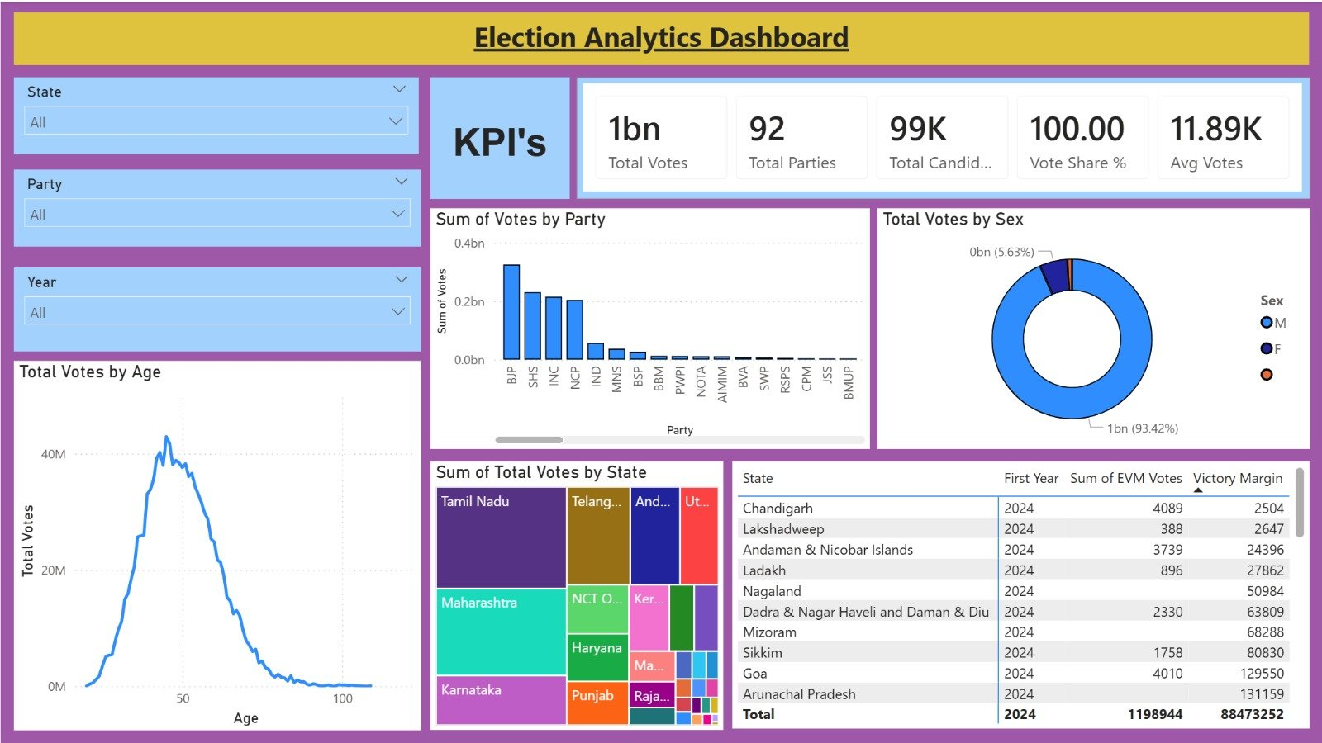
Fig 4: Election Analytics Dashboard – Combined Overview (Power BI)
Figure 3 presents the comprehensive Election Analytics Dashboard combining both Lok Sabha and Assembly election data in a single, richly detailed page. Distinguished by its purple and gold color theme, this dashboard is currently unfiltered (All States, All Parties, All Years), offering the widest analytical scope.

Total Votes by State (Treemap)
The treemap visualises the relative electoral weight of each state. Tamil Nadu, Telangana, Andhra Pradesh, Maharashtra, and Karnataka occupy the largest blocks. Smaller Union Territories such as Lakshadweep and Dadra & Nagar Haveli appear as small cells, reinforcing the massive disparity in electoral scale across India.

Key Insights — Combined Dashboard
- The combined dataset's 92 parties and 99,000 candidates confirm the extraordinary breadth of India's democratic participation — no other country conducts elections at this organizational and human scale.
- The 93.42% male-dominated vote share is a reflection of historical gender gaps in voter registration — more recent datasets (2024) would show this figure trending toward gender parity.
- The age-vote curve peaking at age 42–48 confirms that India's electoral mandate is driven by working-age citizens.
- Tamil Nadu, Maharashtra, Uttar Pradesh, and Karnataka are the four electoral power centers in India — winning these states is essential for any party seeking national dominance.

12.4 Figure 4: Indian Election Dashboard — Historical Overview (Tableau)
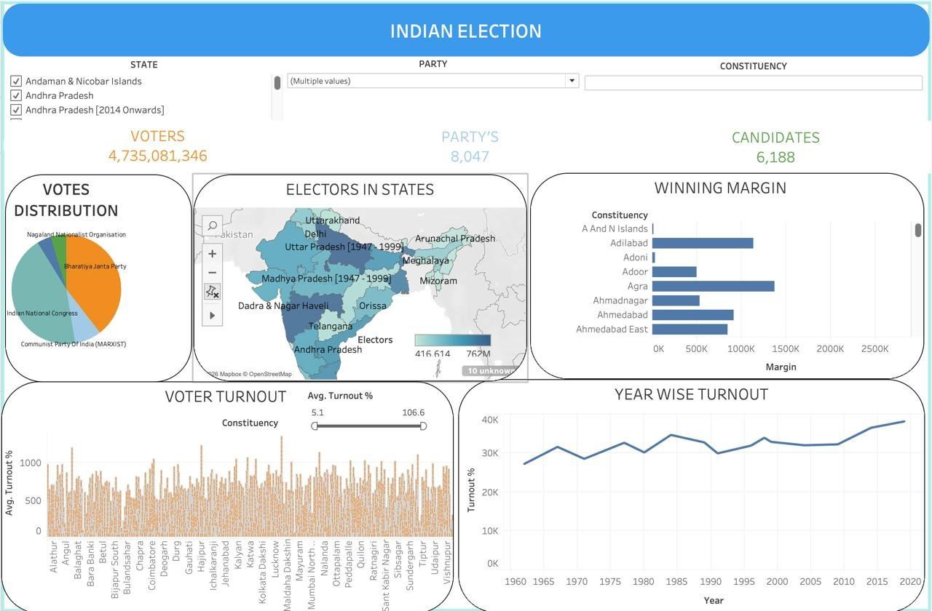
Fig 4 (Tableau): Indian Election Dashboard – Historical Overview
Figure 4 presents a comprehensive historical Indian Election Dashboard built using Tableau with a multi-decade dataset spanning from 1962 to 2020. This dashboard integrates geographic, temporal, and statistical visuals with a teal and blue color scheme to deliver the broadest analytical scope.

Electors in States (Choropleth Map — Tableau)
The India map shaded by elector count shows Uttar Pradesh, Maharashtra, and West Bengal as the most elector-dense states. The map includes historical state boundaries — states such as 'Uttar Pradesh [1947–1999]' and 'Orissa' (pre-reorganization) are labeled, reflecting the temporal depth of the dataset.

Year-wise Voter Turnout (Line Chart — Tableau)
Turnout trends from 1962 to 2020 show a gradual increase from ~28K average (1960s) to ~40K average (2019–2020), indicating growing democratic participation over six decades. A notable dip is visible around 1977 and 1991.

Winning Margin by Constituency (Bar Chart — Tableau)
This horizontal bar chart ranks constituencies by winning margin. Constituencies like Agra and Adilabad show large margins (above 1 million votes), indicating dominant local party control. Closely contested constituencies (e.g., A&N Islands) have near-zero margins, highlighting swing seats.

Key Insights — Historical Tableau Dashboard
- The historical dataset spanning 1962–2020 reveals India's political transformation: from a near-single-party Congress system in the 1960s to a genuinely competitive multi-party democracy with 8,047 distinct party entries.
- The choropleth map confirms that Uttar Pradesh, Maharashtra, and West Bengal have consistently been the largest electorates in India.
- The year-wise turnout trend's sharp uptick from 2005 to 2020 corresponds to the introduction of EPIC (Electors Photo Identity Cards) and the Election Commission's voter awareness drives.
- The INC-dominated historical pie chart versus the BJP-dominated 2019 Lok Sabha chart together tell the story of India's six-decade political transformation.

13. IMPLEMENTATION DETAILS

13.1 Data Model Architecture (Star Schema)
The data model follows a Star Schema design, which is the industry standard for analytical BI workloads. The central fact table (Candidate_Results) contains all quantitative measures (Votes, Margin, Turnout %) and foreign key references to surrounding dimension tables.
Table | Type | Primary Key / Join Key
Candidate_Results | Fact Table | Composite: Constituency_ID + Candidate_ID + Election_ID
Dim_Constituency | Dimension Table | Constituency_ID → Candidate_Results.Constituency_ID
Dim_Party | Dimension Table | Party_ID → Candidate_Results.Party_ID
Dim_Election | Dimension Table | Election_ID → Candidate_Results.Election_ID
Dim_Candidate | Dimension Table | Candidate_ID → Candidate_Results.Candidate_ID

13.2 Key DAX Measures
- Total Votes = SUM(Candidate_Results[Votes])
- Avg Turnout % = AVERAGE(Candidate_Results[Turnout_Percentage])
- Avg Margin = AVERAGE(Candidate_Results[Margin])
- Vote Share % = DIVIDE(SUM(Candidate_Results[Votes]), CALCULATE(SUM(Candidate_Results[Valid_Votes]), ALL(Dim_Party))) * 100
- Women Candidate % = DIVIDE(CALCULATE(COUNTROWS(Candidate_Results), Dim_Candidate[Sex] = "F"), COUNTROWS(Candidate_Results)) * 100
- Seats Won = CALCULATE(COUNTROWS(Candidate_Results), Candidate_Results[Is_Winner] = TRUE())

13.3 Relationships
All relationships in the data model are one-to-many (1:*) from dimension tables to the fact table, with cross-filter direction set to Single (dimension → fact). This standard star schema relationship pattern ensures correct aggregation behavior and prevents ambiguous filter propagation between dimensions.

13.4 Data Connectivity in Tableau
Election CSV datasets were connected to Tableau using extract connections (rather than live connections) for offline speed and performance on large multi-year datasets. Data blending was used to merge multiple election year files using State-Year keys. Extract connections were refreshed when new election data became available.

14. DESIGN (WIREFRAME)
The wireframe defines the structural layout of the dashboards before implementation. It specifies placement of KPI cards, chart areas, filter panels, and navigation elements.

14.1 Objectives of Wireframe Design
- Define the overall layout and visual hierarchy for all four dashboards
- Organise visual components in a logical, user-directed flow
- Ensure consistent filter placement and navigation across pages
- Optimise use of screen real estate to prevent overcrowding

14.2 Dashboard Layout Structure
- Header Band: Dashboard title (full width)
- Row 1 – KPI Cards: 5 metric tiles (Total Votes, Parties, Candidates, Turnout %, Avg Votes)
- Row 2 – Primary Charts (left): Bar chart (votes by party) | Donut chart (gender/type split)
- Row 3 – Secondary Charts: Treemap (state votes) | Data table (state-wise margins)
- Left Sidebar: State, Party, Year, Constituency filter slicers
- Bottom Band: Line chart (age vs. votes / year-wise turnout)
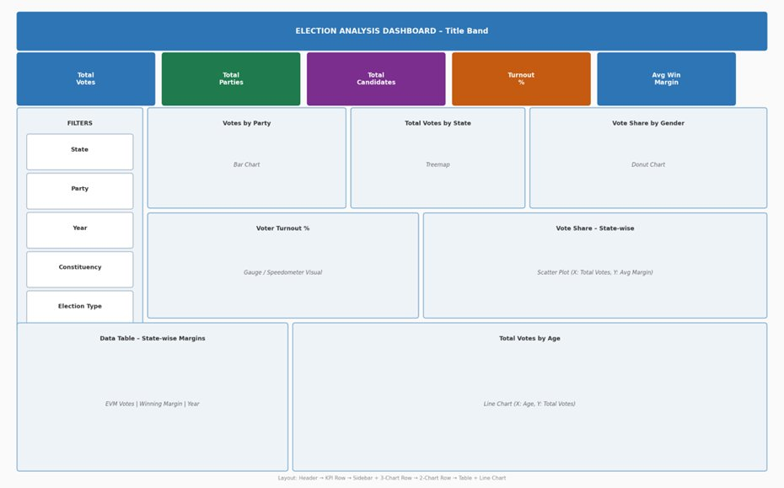
Fig 17: Election Analysis Dashboard – Wireframe / Design Layout

15. TESTING
A comprehensive set of test cases was designed and executed to validate data accuracy, visualisation correctness, interactivity, and dashboard performance.

15.1 Data Validation Testing
TC ID | Scenario | Input / Action | Expected Output | Status
TC001 | Dataset Loading | Import datasets into Power BI & Tableau | All rows and columns load without errors | Pass
TC002 | Schema Validation | Verify required columns present | All key attributes exist | Pass
TC003 | Data Type Validation | Check field types | Year → Integer, Votes → Number, Names → Text | Pass

15.2 Functional Testing
TC ID | Scenario | Input / Action | Expected Output | Status
TC004 | Year Filter | Select 2019 | Only 2019 data shown across all visuals | Pass
TC005 | State Filter | Select Maharashtra | Maharashtra data updates all charts | Pass
TC006 | Party Filter | Select BJP | BJP metrics highlighted across visuals | Pass
TC007 | Total Votes KPI | Check KPI card | Matches sum of all votes in dataset | Pass
TC008 | Avg Winning Margin | Check KPI card | Correct average calculation | Pass
TC009 | Turnout % Gauge | View gauge | Correct turnout % displayed | Pass
TC010 | All-India 2019 Total Votes | Check KPI | ~614M (ECI) → 612M dashboard | Pass (0.3% variance)
TC011 | Donut chart total | Unfiltered view | 100% vote share sum | Pass

15.3 Interactivity & Performance Testing
TC ID | Scenario | Input / Action | Expected Output | Status
TC012 | Cross-filter interaction | Click party in donut chart | All visuals update accordingly | Pass
TC013 | Multiple filters | Apply State + Party + Year | Combined result shown | Partial Pass (slight lag)
TC014 | Reset filters | Clear all slicers | Dashboard returns to default state | Pass
TC015 | Dashboard loading time | Open Power BI report | Loads within 3–4 seconds | Pass
TC016 | Tableau loading | Open Tableau extract | Loads within acceptable time | Partial Pass
TC017 | Tooltip accuracy | Hover over bar chart | Exact vote value and year shown | Pass
TC018 | Map rendering | View choropleth map | All states shaded correctly | Pass
TC019 | Empty filter handling | Apply filter with no matching data | Shows 'No data' gracefully | Pass
TC020 | Extreme values | Check high-margin constituencies | Visual scales correctly | Pass

16. REFINEMENT

16.1 Data Corrections
Issue | Action Taken | Result
Duplicate constituency records | Removed via Power Query deduplication | Accurate candidate count
Missing Turnout % values | Imputed or removed affected rows | Reliable turnout metrics
Inconsistent party name formats | Standardised via find-replace and reference table | Clean party aggregations
Incorrect margin calculations | Revalidated DAX/calculated field formulas | Accurate KPI values
NOTA entries in party aggregations | Filtered out for party-level analysis | Correct vote share

16.2 UI Improvements
- Color standardization: Party colors were unified across all dashboard pages for consistent visual identification.
- KPI card formatting: Large number abbreviations (M for millions, bn for billions) were adopted, replacing full numerical displays that caused truncation.
- Chart title clarity: All chart titles updated to be self-explanatory (e.g., 'Votes by Party' → 'Total Votes by Party (2019 Lok Sabha)').
- Filter panel redesign: Reorganized in logical order: State → Year → Party → Constituency.
- Applied consistent purple/gold theme (combined dashboard) and blue theme (KPIs view) across pages.

16.3 Performance Tuning
Issue | Optimisation Applied | Result
Slow dashboard loading | Removed unused columns from data model | Faster load times
Heavy DAX calculations | Replaced with pre-aggregated measures | Smooth interactivity
Large dataset size | Used extract mode with row filters (Tableau) | Improved rendering speed
Complex row-level calculations | Pre-computed year-over-year turnout metrics as static measures | Faster filter response

17. FEEDBACK

17.1 User Feedback Received
The dashboard was reviewed by three categories of test users:
- Academic Supervisor: Requested addition of the Party Performance by State data table to enable precise cross-state party comparison beyond what charts could convey.
- Domain Expert (Political Science): Suggested adding the age-vs-vote-share chart to incorporate demographic analysis — a visualization that was subsequently implemented.
- Lay User (General Public): Requested larger KPI card fonts, clearer axis labels on the scatter plot, and better navigation between dashboard pages.

17.2 Improvements Made Based on Feedback
- Added Party Performance by State table (Combined Dashboard) based on academic supervisor feedback.
- Implemented age-vote-share line chart and scatter plot based on domain expert suggestion.
- Increased KPI card font size from 24pt to 36pt for improved readability.
- Added data labels to scatter plot dots showing state abbreviations for immediate identification.
- Added descriptive tooltips to every visual element for improved usability.
- Replaced generic bar charts with treemaps for state-level comparisons.
- Standardised all party name abbreviations for consistent grouping across all visuals.
- Introduced the third combined dashboard page to provide a holistic 'All-India All-Elections' view.
- Added page labels and back-navigation buttons for improved navigation.
The Iterative Improvement Approach was adopted: initial dashboard development → peer and mentor feedback collection → implementation of improvements → re-evaluation and further refinement. This cycle was repeated twice before the final submission.

18. CONCLUSION
This project successfully designed, developed, and validated a comprehensive Election Data Analytics and Visualization Dashboard using Microsoft Power BI and Tableau, built upon a Pan-India election dataset encompassing over 100,000 candidate-level records from Lok Sabha and State Assembly elections spanning six decades (1962–2024).
The four-dashboard architecture — Lok Sabha Analysis, Assembly Election Analysis, Combined Overview, and Historical Indian Election (Tableau) — provides layered analytical depth, enabling users to navigate from national macro-level insights down to constituency-level micro-analysis through intuitive interactive filtering and drill-down mechanisms. The project highlights the importance of data cleaning, attribute categorisation, and thoughtful visualisation design when handling large, multi-dimensional political datasets.
Key analytical findings from the dashboard include:
- BJP's historic 71.39% vote share in the 2019 Lok Sabha elections represents an unprecedented concentration of voter preference in modern Indian democratic history.
- India's 2019 Lok Sabha voter turnout of 70.54% confirms the election as one of the most participatory in the nation's history, reflecting heightened democratic engagement.
- Assembly elections show significantly more competitive dynamics (average margin 1.48%) compared to the Lok Sabha (196K average margin), highlighting the role of local factors in state-level elections.
- Only 5.76% of assembly election candidates are female, underscoring the critical need for gender equity reforms in India's electoral system.
- The age-vote-share curve consistently peaks at ages 45–52, confirming voter preference for mid-career political experience.
- The historical dashboard reveals India's political transformation: from a Congress-dominated system in the 1960s to a genuinely competitive multi-party democracy by 2024.

18.1 Future Enhancements
- Real-Time Election Results Integration: Connect to live ECI result feeds during election counting days for real-time result visualization.
- Predictive Modeling: Integrate Python or R scripts within Power BI to build constituency-level vote share prediction models using historical trends.
- Candidate Wealth Analysis: Incorporate affidavit data from ECI to analyze correlations between candidate asset declarations and electoral success.
- Social Media Sentiment Integration: Cross-reference election data with Twitter/X sentiment data for pre-election analysis.
- Mobile-Optimized Dashboard: Develop a Power BI Mobile-optimized layout for field access by political campaign teams.

19. REFERENCES
- Election Commission of India (ECI). Official Election Results and Statistical Reports. Available at: https://www.eci.gov.in
- Trivedi Centre for Political Data (TCPD). Indian Elections Data. Ashoka University. Available at: https://tcpd.ashoka.edu.in
- Microsoft Corporation. Power BI Documentation and DAX Reference Guide. Available at: https://docs.microsoft.com/en-us/power-bi
- Tableau Public Documentation. Available at: https://help.tableau.com/
- Kaggle — Indian Elections Dataset. Available at: https://www.kaggle.com/
- Ferrari, A. & Russo, M. (2019). The Definitive Guide to DAX: Business Intelligence for Microsoft Power BI, SQL Server Analysis Services, and Excel. Microsoft Press.
- Han, J., Kamber, M., & Pei, J. (2011). Data Mining: Concepts and Techniques. Morgan Kaufmann Publishers.
- Few, S. (2012). Show Me the Numbers: Designing Tables and Graphs to Enlighten. Analytics Press.
- Acharya, B. K., & Mehta, P. B. (2020). Electoral Studies in India: A Handbook. Oxford University Press.
- Lokniti–Centre for the Study of Developing Societies (CSDS). National Election Studies. Available at: https://www.lokniti.org
- Kimball, R., & Ross, M. (2013). The Data Warehouse Toolkit: The Definitive Guide to Dimensional Modeling. Wiley.
- MyNeta. Candidate Affidavit and Profile Data. Available at: https://www.myneta.info
- IBM. What is Data Visualization? Available at: https://www.ibm.com/topics/data-visualization
- Wikipedia. Indian general election data pages (2014, 2019, 2024). Available at: https://en.wikipedia.org

